# grep Assignment

**Mandatory:**

1. Use any .c file. Using grep command extract and display
   1. all lines beginning with #include with line numbers

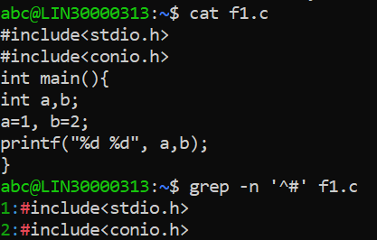

* 1. display all lines which do not begin with #include

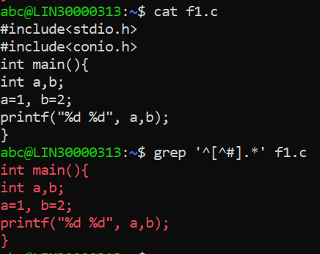

* 1. display the line number of main()

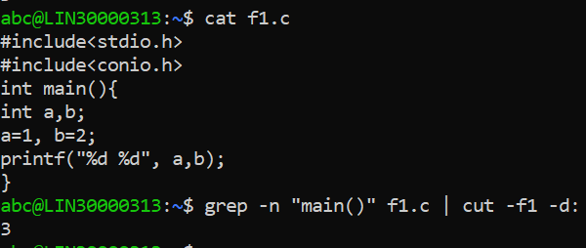

* 1. extract all lines containing characters of opening and closing parathesis {(, ))

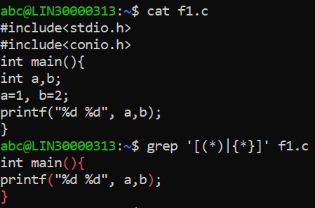

1. Perform the above operations on a set of *.c files
   1. all lines beginning with #include with line numbers

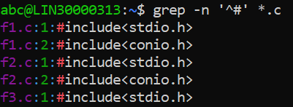

* 1. display all lines which do not begin with #include

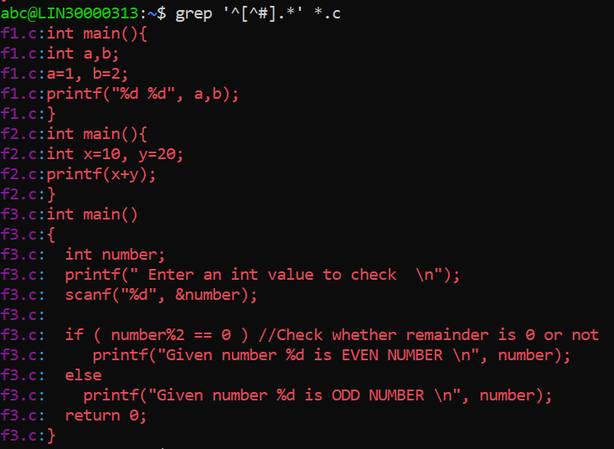

* 1. display the line number of main()

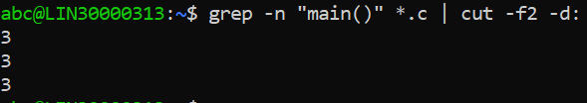

* 1. extract all lines containing characters of opening and closing parathesis {(, ))

